Detecting Land Cover Coastline Change in Cedar Key, Florida

Melissa Moreno

SUR 5386

**1. Statement of the Problem and Literature Review**

Restoration efforts in coastal zones may be strongly influenced by landscape level processes such as changes within adjacent upland watershed characteristics or shoreline features due to erosion or development. Watersheds and shoreline habitats are naturally transient and changes occur over long periods of time due to natural processes including shifts in climate or effects of storms. The Gulf of Mexico coastline, with its low relief geomorphology especially in Florida, is also vulnerable to coastal erosion (Geselbracht et al., 2011). Much of the Florida coastline consists of a 1-meter elevation contour that extends inward anywhere from 3 to 10 kilometers. This low elevation leaves the Florida coastline susceptible to frequent changes. Other types of landscape change occur at different time scales and may have different (and unknown) effects including conversion from forest to agricultural lands to urban areas or development of coastal towns.

Monitoring trends in key characteristics of a watershed over time can provide basic information on how these systems may be changing, and this can motivate actions to improve management and protection of coastal and inland habitats. In this chapter I will develop a data workflow and visualization tool to compile information on to assess trends in major features of the Suwannee River Basin and adjacent coastline. The overall goal is to have a greater understanding of the changes of this local system and document trends in key resources, including agriculture, and habitat type. Examining these trends will provide information to place observed changes in this region such as increased human population density and changes in coastal forests in a broader context in terms of short-term observations or longer-term trends.

**Study Area**

The Suwannee River Basin (SRB) is region of the southeastern United States, ranging from Cordele Georgine to Cedar Key, FL. The SRB is often referred to as one of the most untouched river systems in the United States (Katz & Raabe, 2005). It holds a distinct combination of habitats including swamps, forests, and wetlands The basin also comprises of the second largest river in Florida, the Suwannee River.

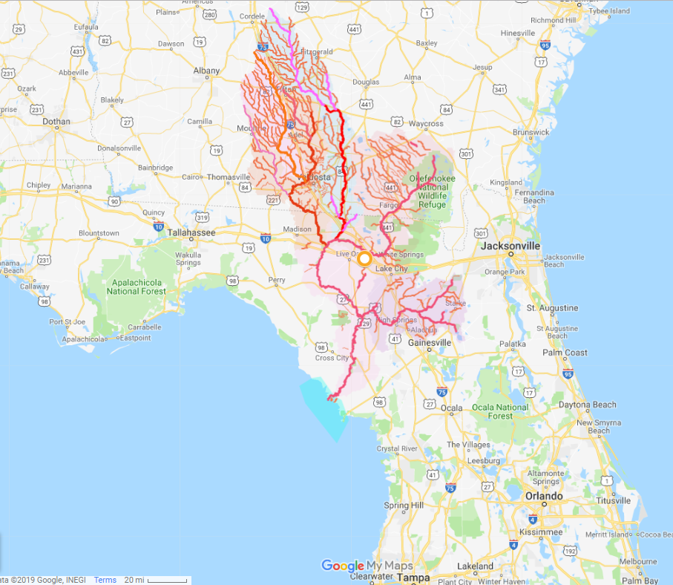

Figure 1- Google map displaying Suwannee River basin in Georgia and Florida. The basin ends in the Suwannee Sound, (turquoise area). Provided by WWALS Watershed Coalition (Suwannee RIVERKEEPER®, http://wwals.net/2017/11/14/suwannee-river-basin-maps/#basingooglemap). The Suwannee River exits on the west coast of Florida (bolded pink line).

The Suwannee River empties into the Big Bend (Figure 1). The Big Bend coastline spans from Crystal River to Apalachee Bay. The Big Bend is largely a marsh-dominated coast and this coastline differs from other coastal areas in the Gulf of Mexico because it is primarily underdeveloped. Over 50% of the shoreline is under conservation protection (Main and Allen 2007), which suggests a low percentage of urbanization, compared to other Florida coastal regions. Due to the low levels of human settlement and construction along this coast, and the large amount of land in conservation, this creates opportunities to examine how the coastline has changed over time from factors that may be occurring naturally, instead of human made impacts.

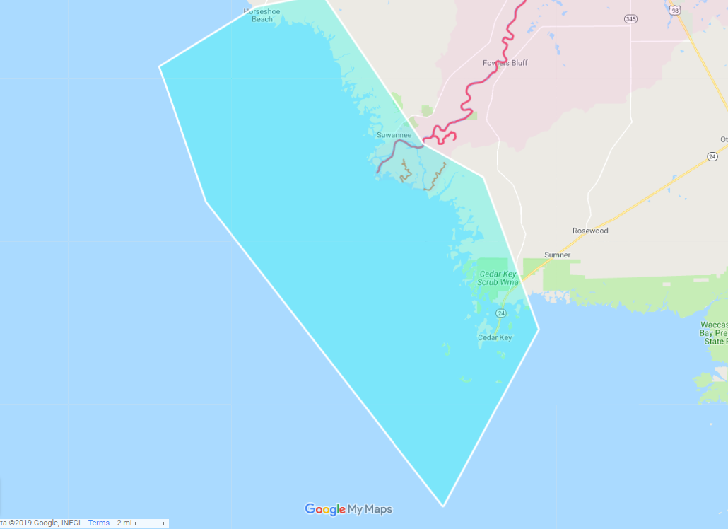

Figure 2 – Zoomed in area of Suwannee River ending at the Big Bend from Figure 1 Google Map.

Significant areas of the land within the basin are protected and conserved by local, State, and Federal agencies, as well as private land owners, and non-government organizations. There are over 50 state and county recreational parks along the river. Along with recreational parks along the basin, there are also monitoring programs that protect and conduct management strategies. According to the Florida State’s Suwannee River Basin Management Action Plan (2018) the lower and middle Suwannee river basin comprises 1.13 million acres where over 750,000 of those acres are protected and designated as part of the priority focus areas for ground water nutrient level reduction as well as implementing restoration management strategies. Much of the land use around the basin, for the lower and middle areas, are comprised of forest, agriculture, and wetlands (Figure 3). There has been very little urban development around the basin, which is very unusual considering that the Florida coastline population was has doubled since 1960, from 8% of the total U.S coastal population to 16% in 2008 (Coastline Population Trends in the United States: 1960 to 2008, 2010)

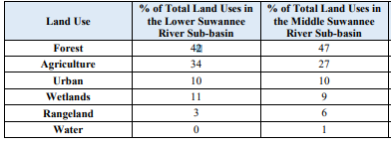

Figure 3- Land uses for each sub-basin in The Suwannee River Basin Management Action Plan, (Suwannee River Basin Management Action Plan (Suwannee River Basin Management Action Plan (Lower Suwannee River, Middle Suwannee River, and Withlacoochee River Sub-basins), 2018).

My proposed study area would focus on an area around Big Bend coastline. The area selected for coastline analysis will an area of interest along the mouth of the Suwannee River; where the SRB ends. Documenting the coastline changes over time in this area is an effort not yet completed or publicly available.

**2. Methodology**

Landsat imagery was acquired online through GloVis, USGS Global Visualization Viewer (https://glovis.usgs.gov/). These images are a spatial resolution of 30 meters. The satellite imagery from November 2005 and September 2009 were downloaded for the Big Bend area as GeoTiff, which is an image with a metadata standard with georeferencing information embedded into it. The satellite image from 2005 is Zone 17 from Landsat5 and satellite image from 2009 is Zone 17 and also from Landsat 5. These images were chosen to reduce errors since they are in the same zone and taken using the same satellite type.

The software ENVI was used to conduct an investigation on the difference in shoreline, and possibly other shoreline features. The steps are documented below.

Both of the satellite images were opened in separate views in ENVI (Figure 3). Then all of the views were geo linked (Figure 4). This is important to make sure that the images are viewed side by side to ensure quality control of the images, and also to check on the metadata associate with the images to make sure they are in the same coordinate projection. Both images were projected as WGS84.

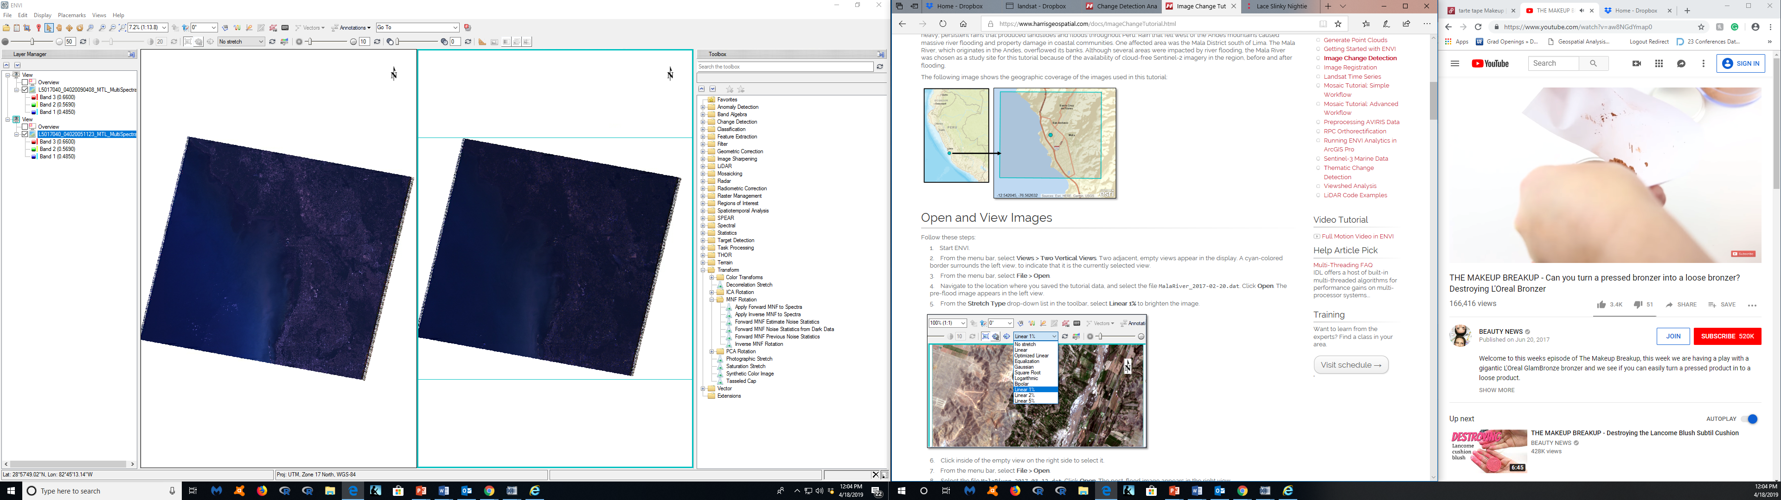

Figure 3- Two views of the satellite imagery in ENVI, 2009 (left), 2005 (right)

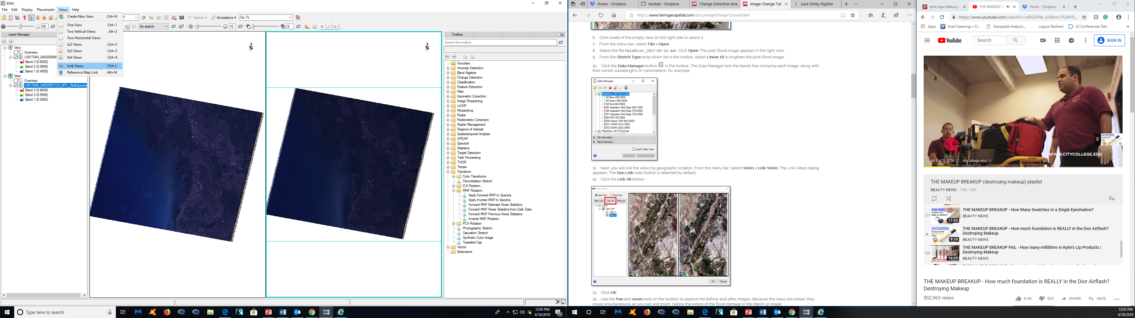

Figure 4- Two views linked, selected all views -> geo link

Viewing information from both Table 1 and 2, the best band choices for this study’s investigation are band 3 and 4. Band 3 is a red wavelength pattern and can discern vegetation slopes. This can be important near shorelines, were more slopes around the shoreline can conclude drastic changes. Band 4 is near infrared wavelength and can determine biomass content and shorelines. All other bands were not investigated for this project.

|  |  |  |  |
| --- | --- | --- | --- |
| **Landsat 4-5**  **Thematic Mapper (TM)** | **Bands** | **Wavelength (micrometers)** | **Resolution (meters)** |
| Band 1 - Blue | 0.45-0.52 | 30 |
| Band 2 - Green | 0.52-0.60 | 30 |
| Band 3 - Red | 0.63-0.69 | 30 |
| Band 4 - Near Infrared (NIR) | 0.76-0.90 | 30 |
| Band 5  - Shortwave Infrared (SWIR) 1 | 1.55-1.75 | 30 |
| Band 6 - Thermal | 10.40-12.50 | 120* (30) |
| Band 7 - Shortwave Infrared (SWIR) 2 | 2.08-2.35 | 30 |

Table 2- Landsat5 band definition as per USGS (<https://landsat.usgs.gov/what-are-band-designations-landsat-satellites>)

|  |  |  |
| --- | --- | --- |
| **Band** | **Wavelength** | **Useful for mapping** |
| Band 1 - Blue | 0.45 - 0.52 | Bathymetric mapping, distinguishing soil from vegetation, and deciduous from coniferous vegetation |
| Band 2 - Green | 0.52 - 0.60 | Emphasizes peak vegetation, which is useful for assessing plant vigor |
| Band 3 - Red | 0.63 - 0.69 | Discriminates vegetation slopes |
| Band 4 - Near Infrared | 0.77 - 0.90 | Emphasizes biomass content and shorelines |
| Band 5 - Short-wave Infrared | 1.55 - 1.75 | Discriminates moisture content of soil and vegetation; penetrates thin clouds |
| Band 6 - Thermal Infrared | 10.40 - 12.50 | Thermal mapping and estimated soil moisture |
| Band 7 - Short-wave Infrared | 2.09 - 2.35 | Hydrothermally altered rocks associated with mineral deposits |
| Band 8 - Panchromatic (Landsat 7 only) | 0.52 - 0.90 | 15 meter resolution, sharper image definition |

Table 3- Landsat 4-5 Thematic Mapper (TM) and Landsat 7 Enhanced Thematic Mapper Plus (ETM+), (<https://landsat.usgs.gov/what-are-best-spectral-bands-use-my-study>)

To notice differences between satellite imagery, steps from the Harris Geospatial Solutions were implemented. The steps used for were for change detection analysis, using “Change Detection Difference Map” (<https://www.harrisgeospatial.com/docs/ChangeDetectionAnalysis.html>). These steps are used to characterize the differences between any pair set of images starting with a initial image and final state image. For this project, the 2005 GeoTiff satellite imagery was set as the initial image, and the 2009 GeoTiff satellite imagery as the final state of the analysis (Figure 5). Both images selected are multispectral.

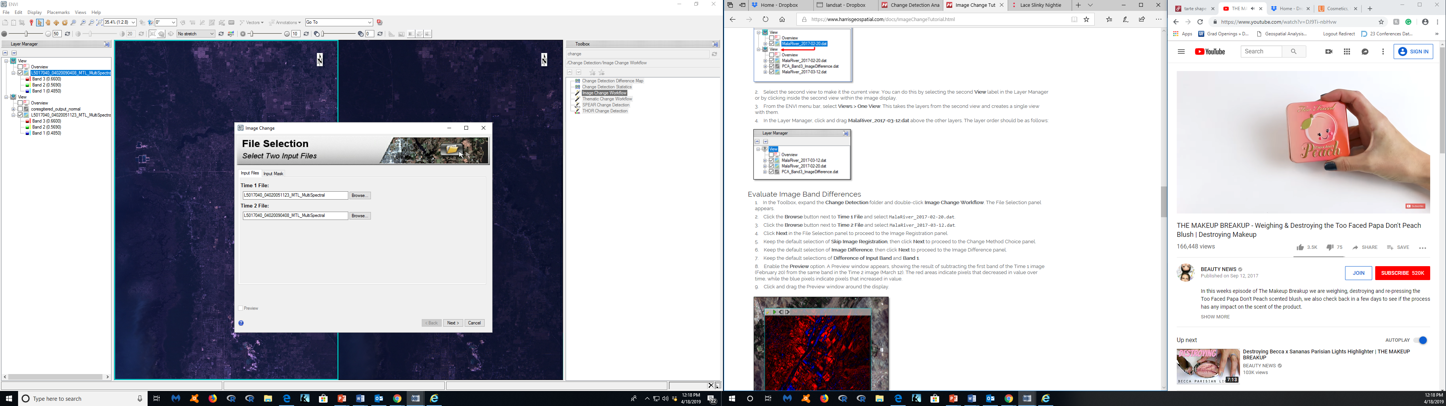

Figure 5- Image Change Workflow-> inputting both images

Once the initial and final images were selected, it was important to select the correct band, Band 3 and Band 4, respectively (Figure 6).

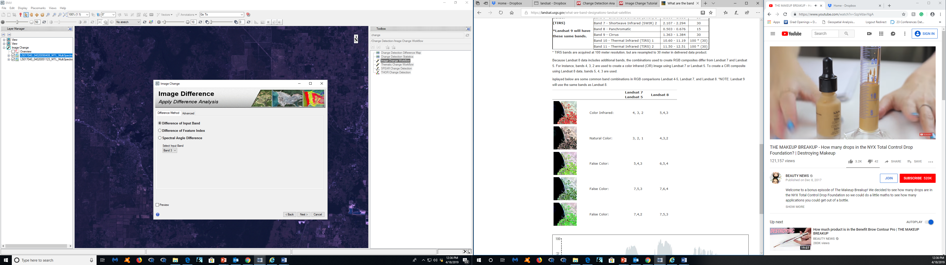

Figure 6- Selecting Band 3 to do the analysis, same step to select Band 4 after Band 3 analysis

For Band 3, which is vegetation slope analysis, I wanted to select measure both the “Increase and Decrease” to show if there is a major difference between growing and declining vegetation slopes (Figure 7). If there is a decrease in vegetation slopes around the shoreline it could mean that the shoreline around those observations are degrading. All default parameters suggested by the software were applied.

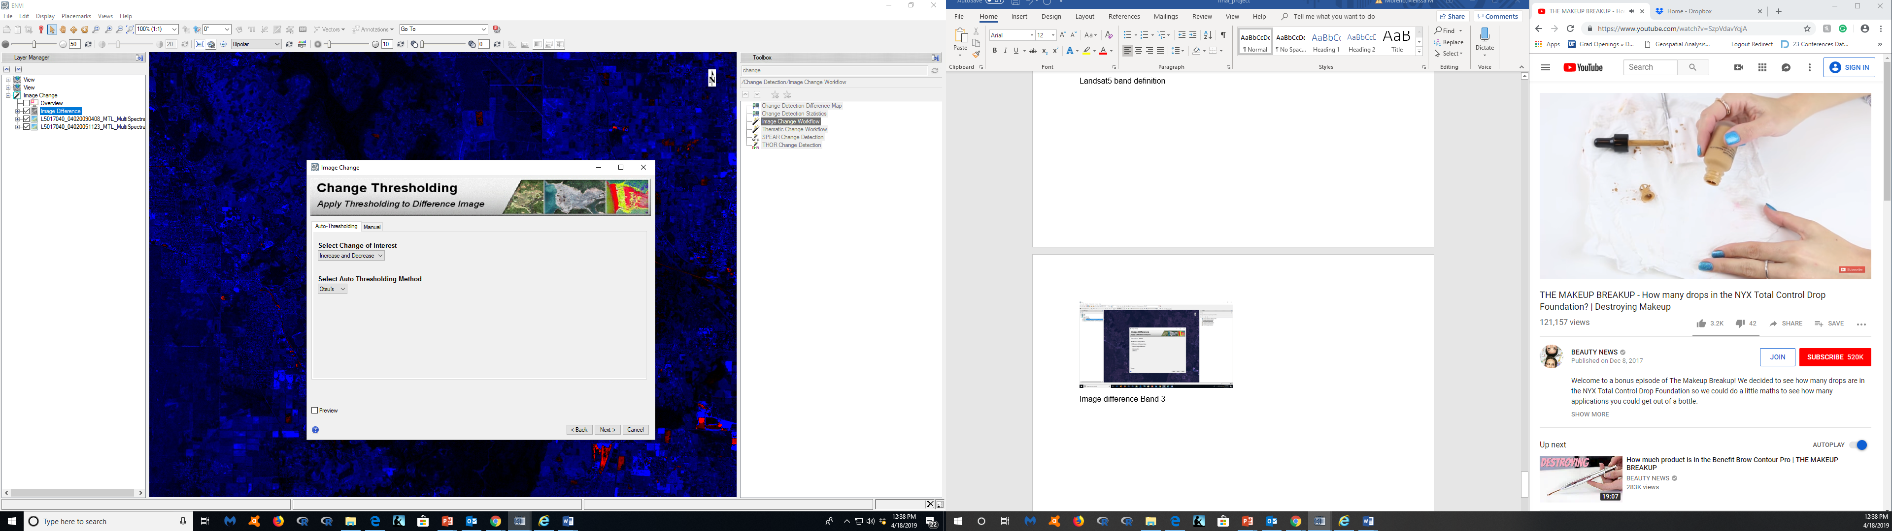

Figure 7- Analysis of Band 3, selecting to investigate the Increase and Decrease between the band on both images

After applying the threshold, we can view the final analysis of both images. The analysis is overlaid on top of the 2009 satellite imagery map so have a good clear view of where these increases and decreases are occurring (Figure 8).

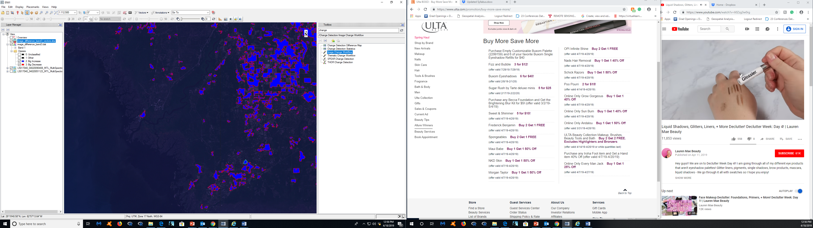

Figure 8- Band 3 Increase is blue, decrease is red, overlaid on the 2009 map (which is the latest image)

The same steps and parameters were applied for Band 4, with the exception of selecting “Decrease only”. This was implemented instead of “Increase and Decrease”, because I am most interested in shoreline loss during these two time frames. The final result shows that there are declining shorelines and vegetation areas around the Big Bend.

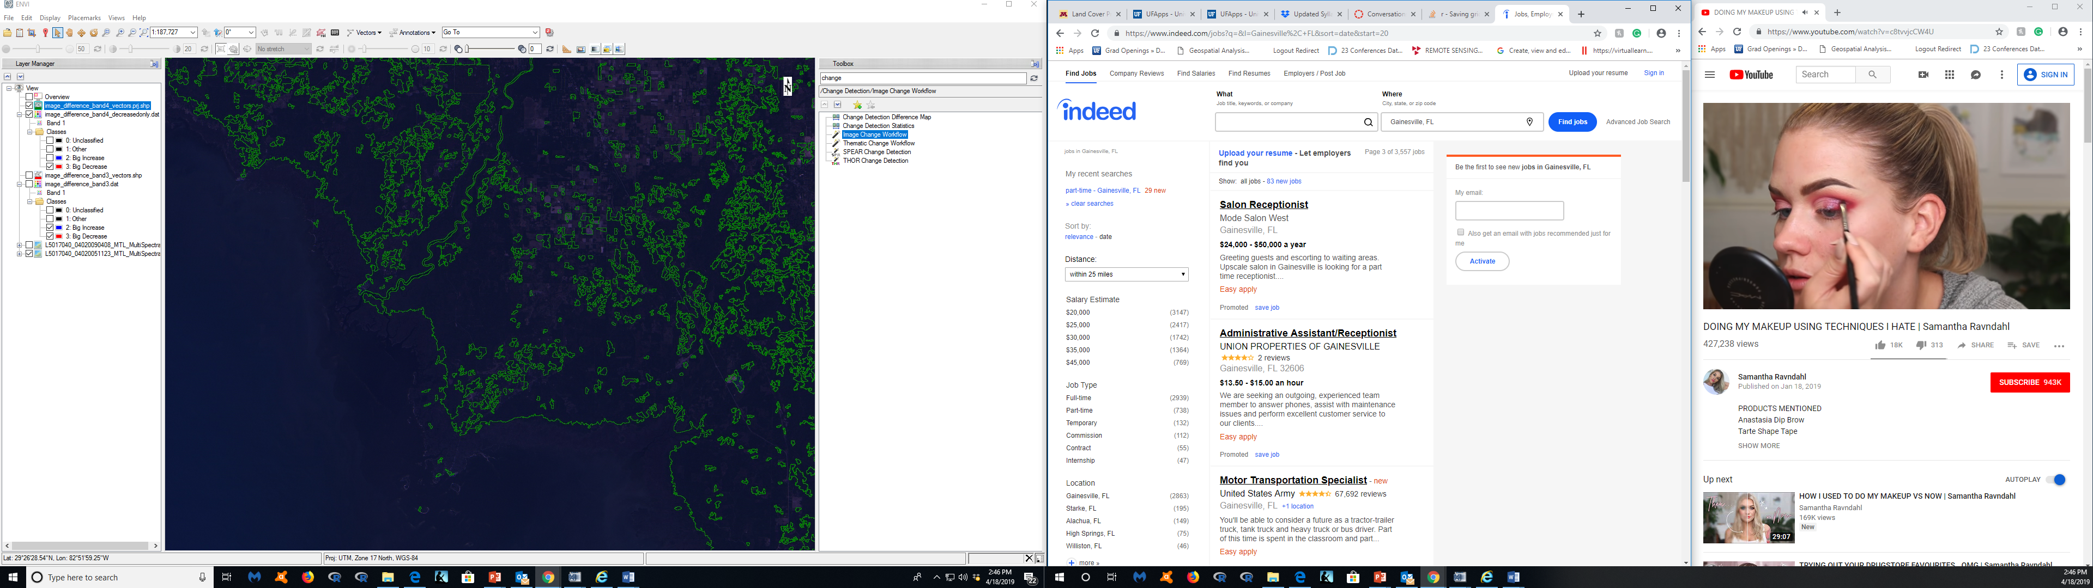

Figure 9- “Decrease Only” in Band 4, same paraments as Band 3, overlaid on the 2009 map (which is the latest image)

**3. Results and Discussion**

Band 3 results-

The results for Band 3 image difference analysis (Figure 8) were detectable. The results show that where there are decreases in vegetation slope (red). There is also an increase (blue) a near the same areas as the decreases. The areas are further from the shoreline and closer to the smaller cities that are around Cedar Key, FL. I am also noticing that changed areas are mostly clustered.

Band 4 results-

I was expecting that there would be shoreline decreases between the imagery, but I did not expect that the whole coastline to be affected. It also seems that biomass content has also been affected, in different areas that were not necessarily affected by the vegetation slope increase and decrease. It seems that almost every area of the map has seen some kind of biomass content or shoreline decrease.

Discussion

It was surprising to see that in Band 3, there was more difference in vegetation slope away from the shoreline, than nearer to the shoreline. I do research around these areas, and I haven’t noticed this change myself, but speaking with Cedar Key locals, they have mentioned that a lot has changed with vegetation and shoreline has changed in just the last decade. The imagery were only a four year difference, and there is detectable changes between these maps. For Band 4, I am not surprised that so much of the shoreline has a detectable change. That makes me question about the protected areas about the Big Bend, and if they are actually effective in preventing shoreline loss. I also notice that around the Suwannee River there is a noticeable decrease in biomass content as well. It is unclear, based on these images, if the decreases are due to direct or indirect causes of human influence, but it is assumed that almost all drastic environmental changes are human influenced, but that’s up for debate.

**4. Conclusion**

Additional research from this will be conducted during my Master’s thesis. This project was a very informative first step to see the impact a few years can make to my study area’s coastline. At this time, I am not looking into why the shoreline is degrading over time, just how it is degrading. Hopefully my research will show how much and what exactly is changing. Noticing these changes will help agencies and local determine if action should be taken to help protect these shorelines. Agencies might be interested in additionally protecting these shorelines since most of the coast along the Big Bend is currently protected, but there are no active management programs to help restore lost shorelines.

# Bibliography

Allen, R., & Iii, M. (2012). *ESTABLISHING VISUAL BASED AND DATUM BASED SHORELINES AND SHORELINE UNCERTAINTIES ON A SANDY COAST: CAPE CANAVERAL, FLORIDA.*

Desantis, L., Bhotika, S., Williams, K., & Putz, F. (2007, 11). Sea-level rise and drought interactions accelerate forest decline on the Gulf Coast of Florida, USA. *Global Change Biology, 13*(11), 2349-2360.

Epstein, J., Pine, W., Romagosa, C., Scott, M., Phillips, C., Marion, C., & Baiser, B. (2018, 11 1). State- and Regional-Scale Patterns and Drivers of Freshwater Fish Functional Diversity in the Southeastern USA. *Transactions of the American Fisheries Society, 147*(6), 1179-1198.

Geselbracht, L., Freeman, K., Kelly, E., Gordon, D., & Putz, F. (2011, 7). Retrospective and prospective model simulations of sea level rise impacts on Gulf of Mexico coastal marshes and forests in Waccasassa Bay, Florida. *Climatic Change, 107*(1), 35-57.

Katz, B., & Raabe, E. (n.d.). *Suwannee River Basin and Estuary: An Integrated Watershed Science Program White Paper Open-File Report 2005-1210.*

Keys, F. (n.d.). *Confronting Climate Change in the Gulf Coast Region Prospects for Sustaining Our Ecological Heritage Southeastern Plain South Florida Coastal Plain.*

Langston, A., Kaplan, D., & Putz, F. (2017, 12 1). A casualty of climate change? Loss of freshwater forest islands on Florida's Gulf Coast. *Global Change Biology, 23*(12), 5383-5397.

Raabe, E., Streck, A., & Stumpf, R. (n.d.). *Historic Topographic Sheets to Satellite Imagery: A Methodology for Evaluating Coastal Change in Florida's Big Bend Tidal Marsh.*

Seavey, J., Pine, W., Frederick, P., Sturmer, L., & Berrigan, M. (2011, 10 21). Decadal changes in oyster reefs in the Big Bend of Florida's Gulf Coast. *Ecosphere, 2*(10), art114.

Wilson, S., & Fischetti, T. (2010). *Coastline Population Trends in the United States: 1960 to 2008 Population Estimates and Projections Current Population Reports.*

Zhang, K., Douglas, B., & Leatherman, S. (2004). *GLOBAL WARMING AND COASTAL EROSION.*